St Joseph’s School
Southern Cross
2022 Kindergarten
Parent Handbook

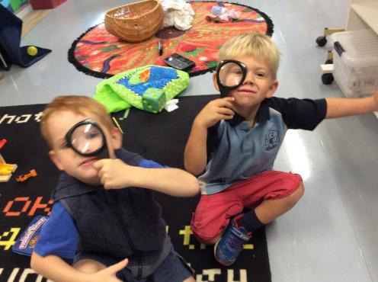

School Prayer
Dear Jesus,
I offer you today with all my ups and downs.
All my prayers and all my words, all my happy times and all my sad times.
Help me, to come to the end of this day a better person,
Having loved you and others,
Especially my family and school mates.
Amen

EARLY CHILDHOOD PHILOSOPHY
St Joseph’s School endeavours to create a comfortable atmosphere for all children, which will enhance their self-esteem, confidence, dignity, respect and willingness to learn. The school is committed to 21st Century Learning and Inspiring Hope based on the Gospel Values. We strive for excellence in all areas and involve the parents and community in the education of the children of our school. We encourage to lead children to integrate faith, life and culture, centred on a play based curriculum. We strive for this in an environment where children feel supported, safe and secure by catering for individual abilities.
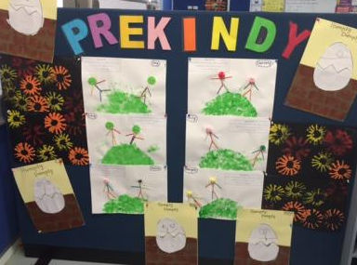
Welcome to Kindergarten at St Joseph’s Southern Cross
The program is play-based and provides children with meaningful experiences based on the Early Years Framework. The program helps to develop independence and creativity by offering interesting and fun activities that are developmentally appropriate in a structured format. The program follows a routine where the children are in the care of a Teacher and an Education Assistant for the duration of the session.

Our Vision
St Joseph’s Southern Cross offers a contemporary Catholic Education that inspires hope and is inclusive of all. Centred on Christ, we provide high quality programs with a strong focus on taking action for good in the world.

Students at St Joseph’s are supported and extended in our innovative curriculum. Staff are committed to the learning and growth of young people. Quality teaching is consistently demonstrated and individualised to set high standards for every learner. The students learn the social, emotional and academic skills needed for lifelong learning. Digital Literacy is a valued learning area where students learn new skills and consolidate those already known.

Communication
All staff at St Joseph’s strive to ensure communication with the school community is of the highest standard. Staff work collaboratively to promote student success and are encouraged to participate in professional development, to model ongoing learning to update skills and knowledge and challenge current practices.
We have a very supportive parent population. Parents are encouraged to approach the school comfortably when needed. They understand that school matters are kept confidential and only discussed in our school environment.
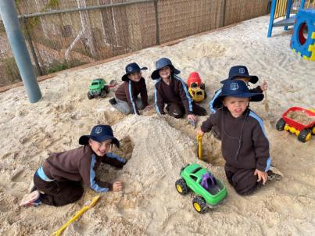
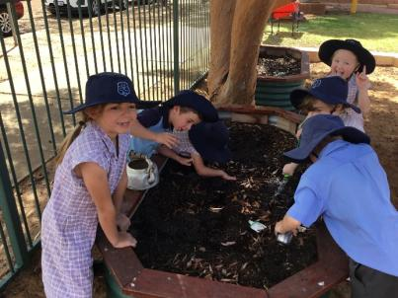

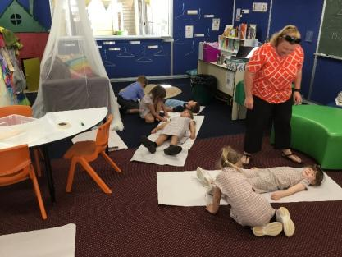
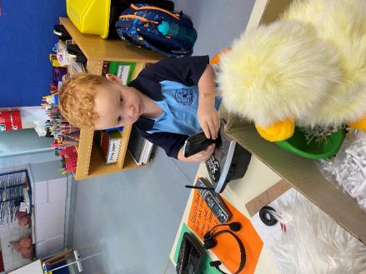

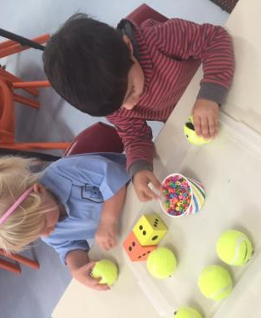
Kindergarten Staff
Kindergarten is staffed by one Teacher, Miss Chantelle Stock and one Education Assistant, Mrs Petrina Pearce, Mrs Michelle Pedrin or Mrs Lorrae Carlson.

SESSION TIMES
Tuesday: 8:50am- 2:30pm
Wednesday: 8:50am- 3:10pm
Thursday: 8:50am- 3:10pm

Doors open at 8:30am
Please remain with your children until the staff open the doors. Parents are invited to come into the classroom to assist their children with unpacking and then watch their children write their name or share a book or puzzle with their child until the bell rings at 8:50am.
On entering the room, children are requested to place their lunch box in the fridge, place their water bottle in the designated spot and place their bag outside.

Pick up is 3:10pm except for Tuesdays (2:30pm)
It is important that children are collected promptly as staff need to prepare for their next lesson. If you are running late to pick up your child, please call the school on 90492100.

At departure time, the teacher will call the child’s name when she notices their caregiver has arrived. If you wish for your child to be collected by another person, please let the teacher know and ensure that person is on the ‘permission to pick up’ list.

Please note:
We ask that parents ensure all children (including siblings) refrain from playing on the playground equipment both before and after these times.
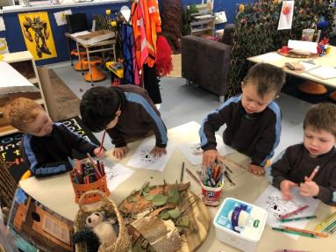
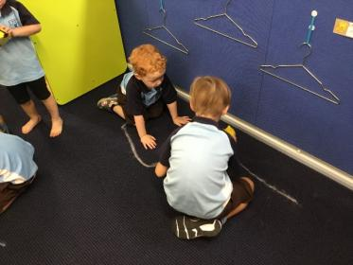

What to bring
- A piece of fruit or vegetable cut up for crunch and sip
- Clearly labelled drink bottle containing only water
- A change of clothes to keep in their bag (please ensure these are clearly labelled)
- A backpack
- A lunchbox containing lunch and healthy snacks for recess

What to wear
Please send your children in comfortable, casual clothes. School uniform is not compulsory for Kindergarten, however only the Pre Primary school sport uniform is available for purchase. Please contact the school office on 90492100.
We recommend sand shoes or sandals (not thongs) to be worn, as your children will have opportunities to climb and play in the sand pit and your child’s safety is paramount. Children are able to take their shoes off if they wish.

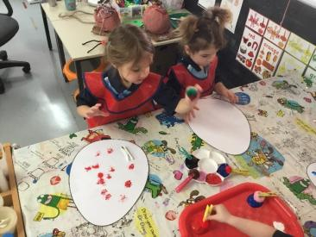
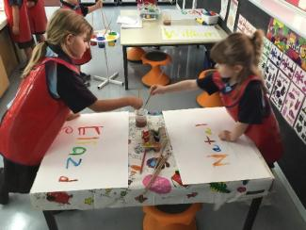

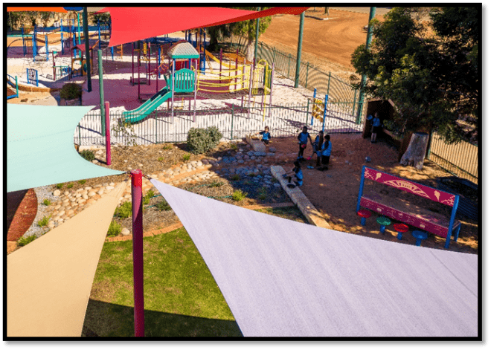

Illness
For the sake of your child and the health of others, please do not send your child to school if they are sick or unwell. If your child becomes unwell during school hours, you will be notified immediately. Please ensure your contact details are kept up to date.

Behaviour Management
At St Joseph’s School we use the 123 Magic as a whole school behaviour management system. All children get three warnings and if their behaviour persists they will be asked to go to ‘take 5’ to have some thinking time.

Helping your child write their name
If you are assisting your child with name writing and recognising their own name, please be aware that at St Joseph’s Southern Cross the required font is ‘NSW’ Foundation font. Names are written with only a capital letter for the first letter of their name (never all capitals) and the capital letter is larger than the following letters. It is very difficult for a child to ‘unlearn’ incorrect letter formations.

Aa Bb Cc Dd Ee Ff Gg Hh Ii Jj Kk Ll Mm
Nn Oo Pp Qq Rr Ss Tt Uu Vv Ww Xx Yy Zz
Example: Jessica

Keeping informed
Students in Kindergarten will receive a newsletter fortnightly. Please ensure you check the newsletter for upcoming school events and information. Kindergarten families are a part of our school community and we encourage attendance at school events and functions. An SMS system is in place for all families to be updated on happenings within the school. In the classroom we also use Seesaw to post information and photos of the students engaging in daily activities.

Useful items
In Kindergarten we are often involved in lots of craft activities that require odds and ends, If you have any of the following we would be grateful if you could bring them to the Early Childhood room, ie: buttons, boxes, beads, felt, material, wrapping paper, shoe boxes, corks etc.
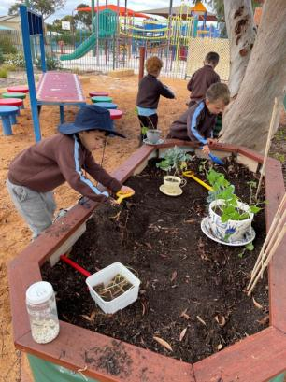
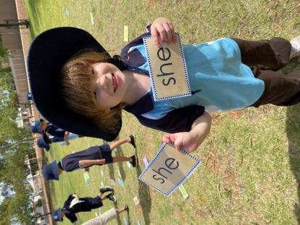

Contact information
If you have any queries or questions, please do not hesitate to contact the school office on 9049 2100 or email the school at admin@stjoessx.wa.edu.au

Staff can be approached before school with small queries, alternatively, an appointment can be made if necessary.

Dealing with Disputes and Complaints

