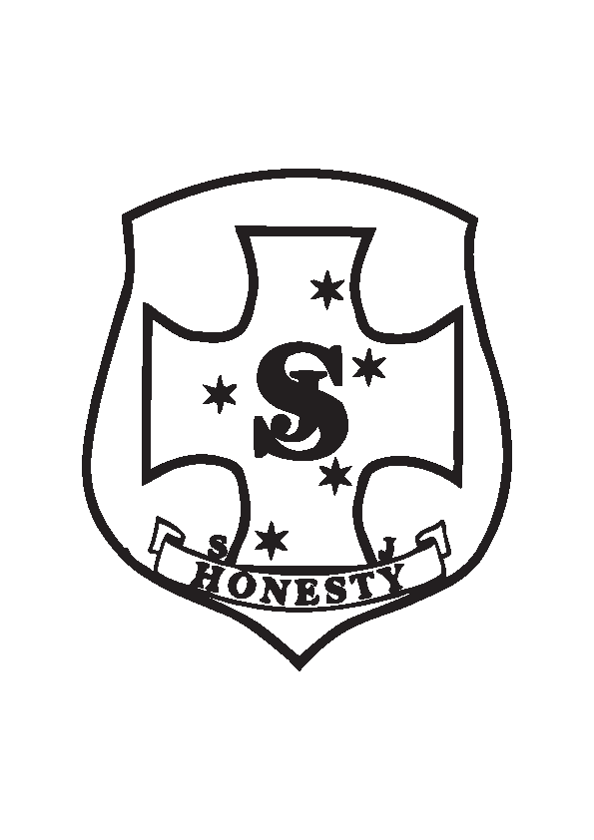

ST JOSEPH'S UNIFORM REQUIREMENTS

Girls Year 1 – Year 6 UNIFORMS

SUMMER Term 1 & 4
Uniform  Summer Tunic  - Sandals (Brown, Black or Navy Blue)  - School Shoes (Black)  - Grey school socks  - Blue School Jumper  - School Hat | Sports Uniform  School Tracksuit/ Brown Skort  School Sports Polo Shirt  - Sport Shoes (Black /Blue or White)  - Blue sports socks  - School Hat
Boys Year 1 – Year 6 UNIFORMS

SUMMER Term 1 & 4
Uniform  Grey School Shorts  - Blue Shirt –Short Sleeve  - Sandals (Brown, Black or Navy Blue)  - School Shoes (Black)  - Grey school socks  - Blue School Jumper  - School Hat | Sports Uniform  Brown School Tracksuit/Shorts  School Sports Polo Shirt  - Sport Shoes (Black /Blue or White)  - Blue sports socks  - School Hat

PRE PRIMARY Summer UNIFORM & Optional KINDERGARTEN Uniform

SUMMER Term 1 & 4
Girls  - Sports Uniform  Brown Skort / School Tracksuit  Sports Polo Shirt  - Sandals (black, brown or navy)  - Sport Shoes (Black /Blue or White)  - Blue sports socks  - School Hat | Boys  - Brown Shorts/ School Tracksuit  School Sports Polo Shirt  - Sandals (black, brown or navy)  - Sport Shoes (Black /Blue or White)  - Blue sports socks  - School Hat

