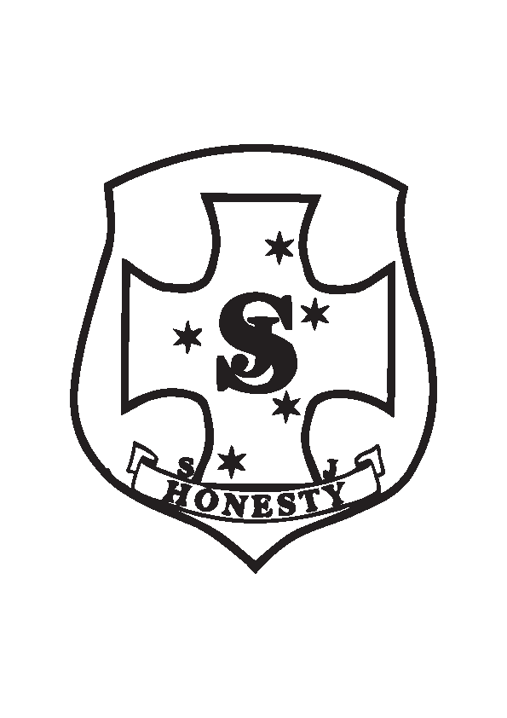St Joseph’s P & F Uniform Shop
February 2022

Uniforms can be ordered by contacting the school office.

Please Note:
Payment details will be changing as at Term 1 2023. Please contact the school for details.

ITEM | DESCRIPTION | SIZE | PRICE
School Bags | Backpack | Large | $45.00
Hats | Slouch – Navy | XS – XL | $10.00
Jumpers | Blue Winter Woollen | 6 – 8  10 – 16 | $25.00
Sports Polo | Blue Girls/Boys | 4 – 16 | $20.00
Skorts | Brown Girls Sports | 4 – 16 | $18.00
Shirts | Blue Short sleeved  Blue Long Sleeved | 6 – 16  6 – 16 | $16.00  $20.00
Shorts | Boys Brown Shorts  Boys Grey Shorts | 6-16  6-16 | $16.00  $1600
Slacks | Grey Winter Boys | 6 – 16 | $27.00
Skirts | Girls Grey | 4-5yr, 6-7yr,  7-8yr, 10-11yr, 11-12yr | $16.00
Socks | Sport – Blue  Girls/Boys – Grey | 9-12, 13-3, 2-8  9-12, 13-3, 2-8 | $3.00  $3.00
Tights | Girls- Grey | 4-6yr, 6-8yr,  8-10yr, 14-16yr | $9.00
Track pants  Track tops  (Brown Jumper) | Brown Winter Sport  Brown Winter Sport | 4 – 16  6 – 16 | $24.00  $30.00
Dress | Girls Summer | 4 – 16 | $45.00
Winter Jacket | Blue Waterproof jacket | 6-16 | $30.00
School Scarf | Blue & emblem | One size | $10.00
School Beanie | Blue | One size | $6.00

Payment must be made when you order & prices are subject to change.

