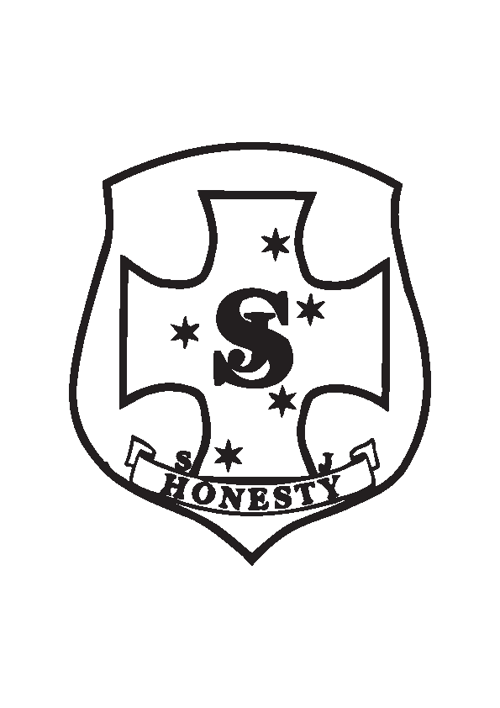

ST JOSEPH'S WINTER UNIFORM REQUIREMENTS
TERM 2 AND 3

Girls Year 1 – Year 6 UNIFORMS

WINTER Term 2 & 3
Uniform  - Grey School Skirt & Grey Tights  - Blue Shirt – Long or Short Sleeve  - Blue School Jumper  - Black School Shoes  - Grey Socks  - School Winter Jacket, Scarf & beanie- optional  - School Hat | Sports Uniform  - School Tracksuit / Skort  - School Sports Polo Shirt  - Sport Shoes (Plain Black or White)  - Blue Sports Socks  - School Winter Jacket, Scarf & beanie-optional  - School Hat

Boys Year 1 – Year 6 UNIFORM

WINTER Term 2 & 3
Uniform  - Grey Trousers  - Blue Shirt – Long or Short Sleeve  - Blue School Jumper  - Black School Shoes  - Grey Socks  - School Hat  - School Winter Jacket, Scarf & beanie-optional | Sports Uniform  - School Tracksuit/Brown Shorts  - School Sports Polo Shirt  - Sport Shoes (Plain Black or White)  - Blue Sports Socks  - School Hat  - School Winter Jacket, Scarf & beanie-optional

PRE PRIMARY UNIFORM & Optional KINDERGARTEN Uniform

WINTER Term 2 & 3
Girls - Sports Uniform  - School Tracksuit/Brown Sport Skorts  - Sports Polo Shirt  - Sport Shoes(Plain Black or White)  - Blue Sports Sock  - School Hat  - School Winter Jacket, Scarf & beanie- optional | Boys- Sports Uniform  - School Tracksuit/Brown Sport Short  - School Sports Polo Shirt  - Sport Shoes(Plain Black or White)  - Blue Sports Socks  - School Hat  - School Winter Jacket, Scarf & beanie-optional

