
St. Joseph’s Catholic Primary School
51 Altair Street
(PO Box 89)
SOUTHERN CROSS
Western Australia 6426
ABN 21 251 707 478
Tel: (08) 9049 2100
Email: admin@stjoessx.wa.edu.au
Web: www.stjoessx .wa.edu.au
Uniform Order Form 2025
Students in Year One to Six are required to wear the school uniform. Payment must be made upon collection of uniforms and prices are subject to change. Eftpos facilities are available at the office and cash is accepted.
Name:__________________________________________

Phone:_________________________________________

Girls |  | Sizes Available | Size | Qty | Price | Total $
Skorts | 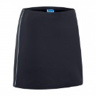 | 4,6,8,10,12,14,16 |  |  | $18.00
Boys
Shorts | 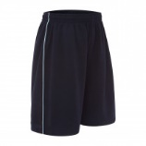 | 4,6,8,10,12,14Y, 16Y |  |  | $15.00
Unisex
Jacket | 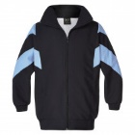 | 4,6,8,10,12,14Y,16Y |  |  | $35.00
Track Pant | 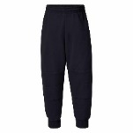 | 4,6,8,10,12,14Y,16Y |  |  | $20.00
Blue Sports Polo | 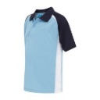 | 4,6,8,10,12,14Y,16Y |  |  | $25.00
Socks | White | 9-12, 13-3 & 2-8 |  |  | $3.00
Navy Tights | Pack 3  Individual | 3-5, 6-9 and 10 –12  11-14yrs |  |  | $15.00  $10.00

Total- $
Paid Cash/Eftpos
Date:

