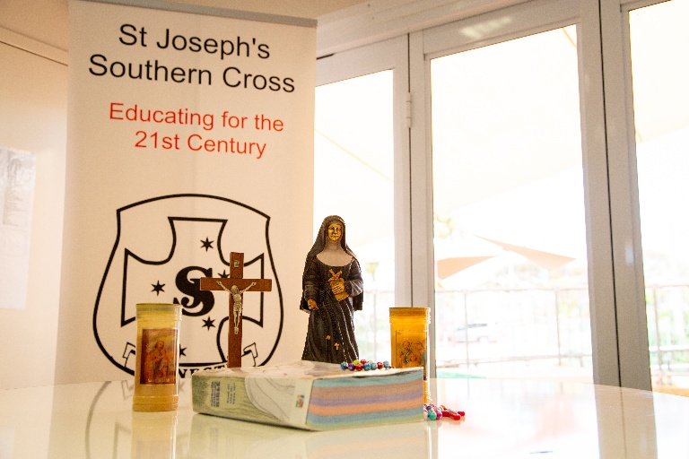
2025 - 2027
St. Joseph’s School
Southern Cross
CATHOLIC SCHOOL
IMPROVEMENT PLAN
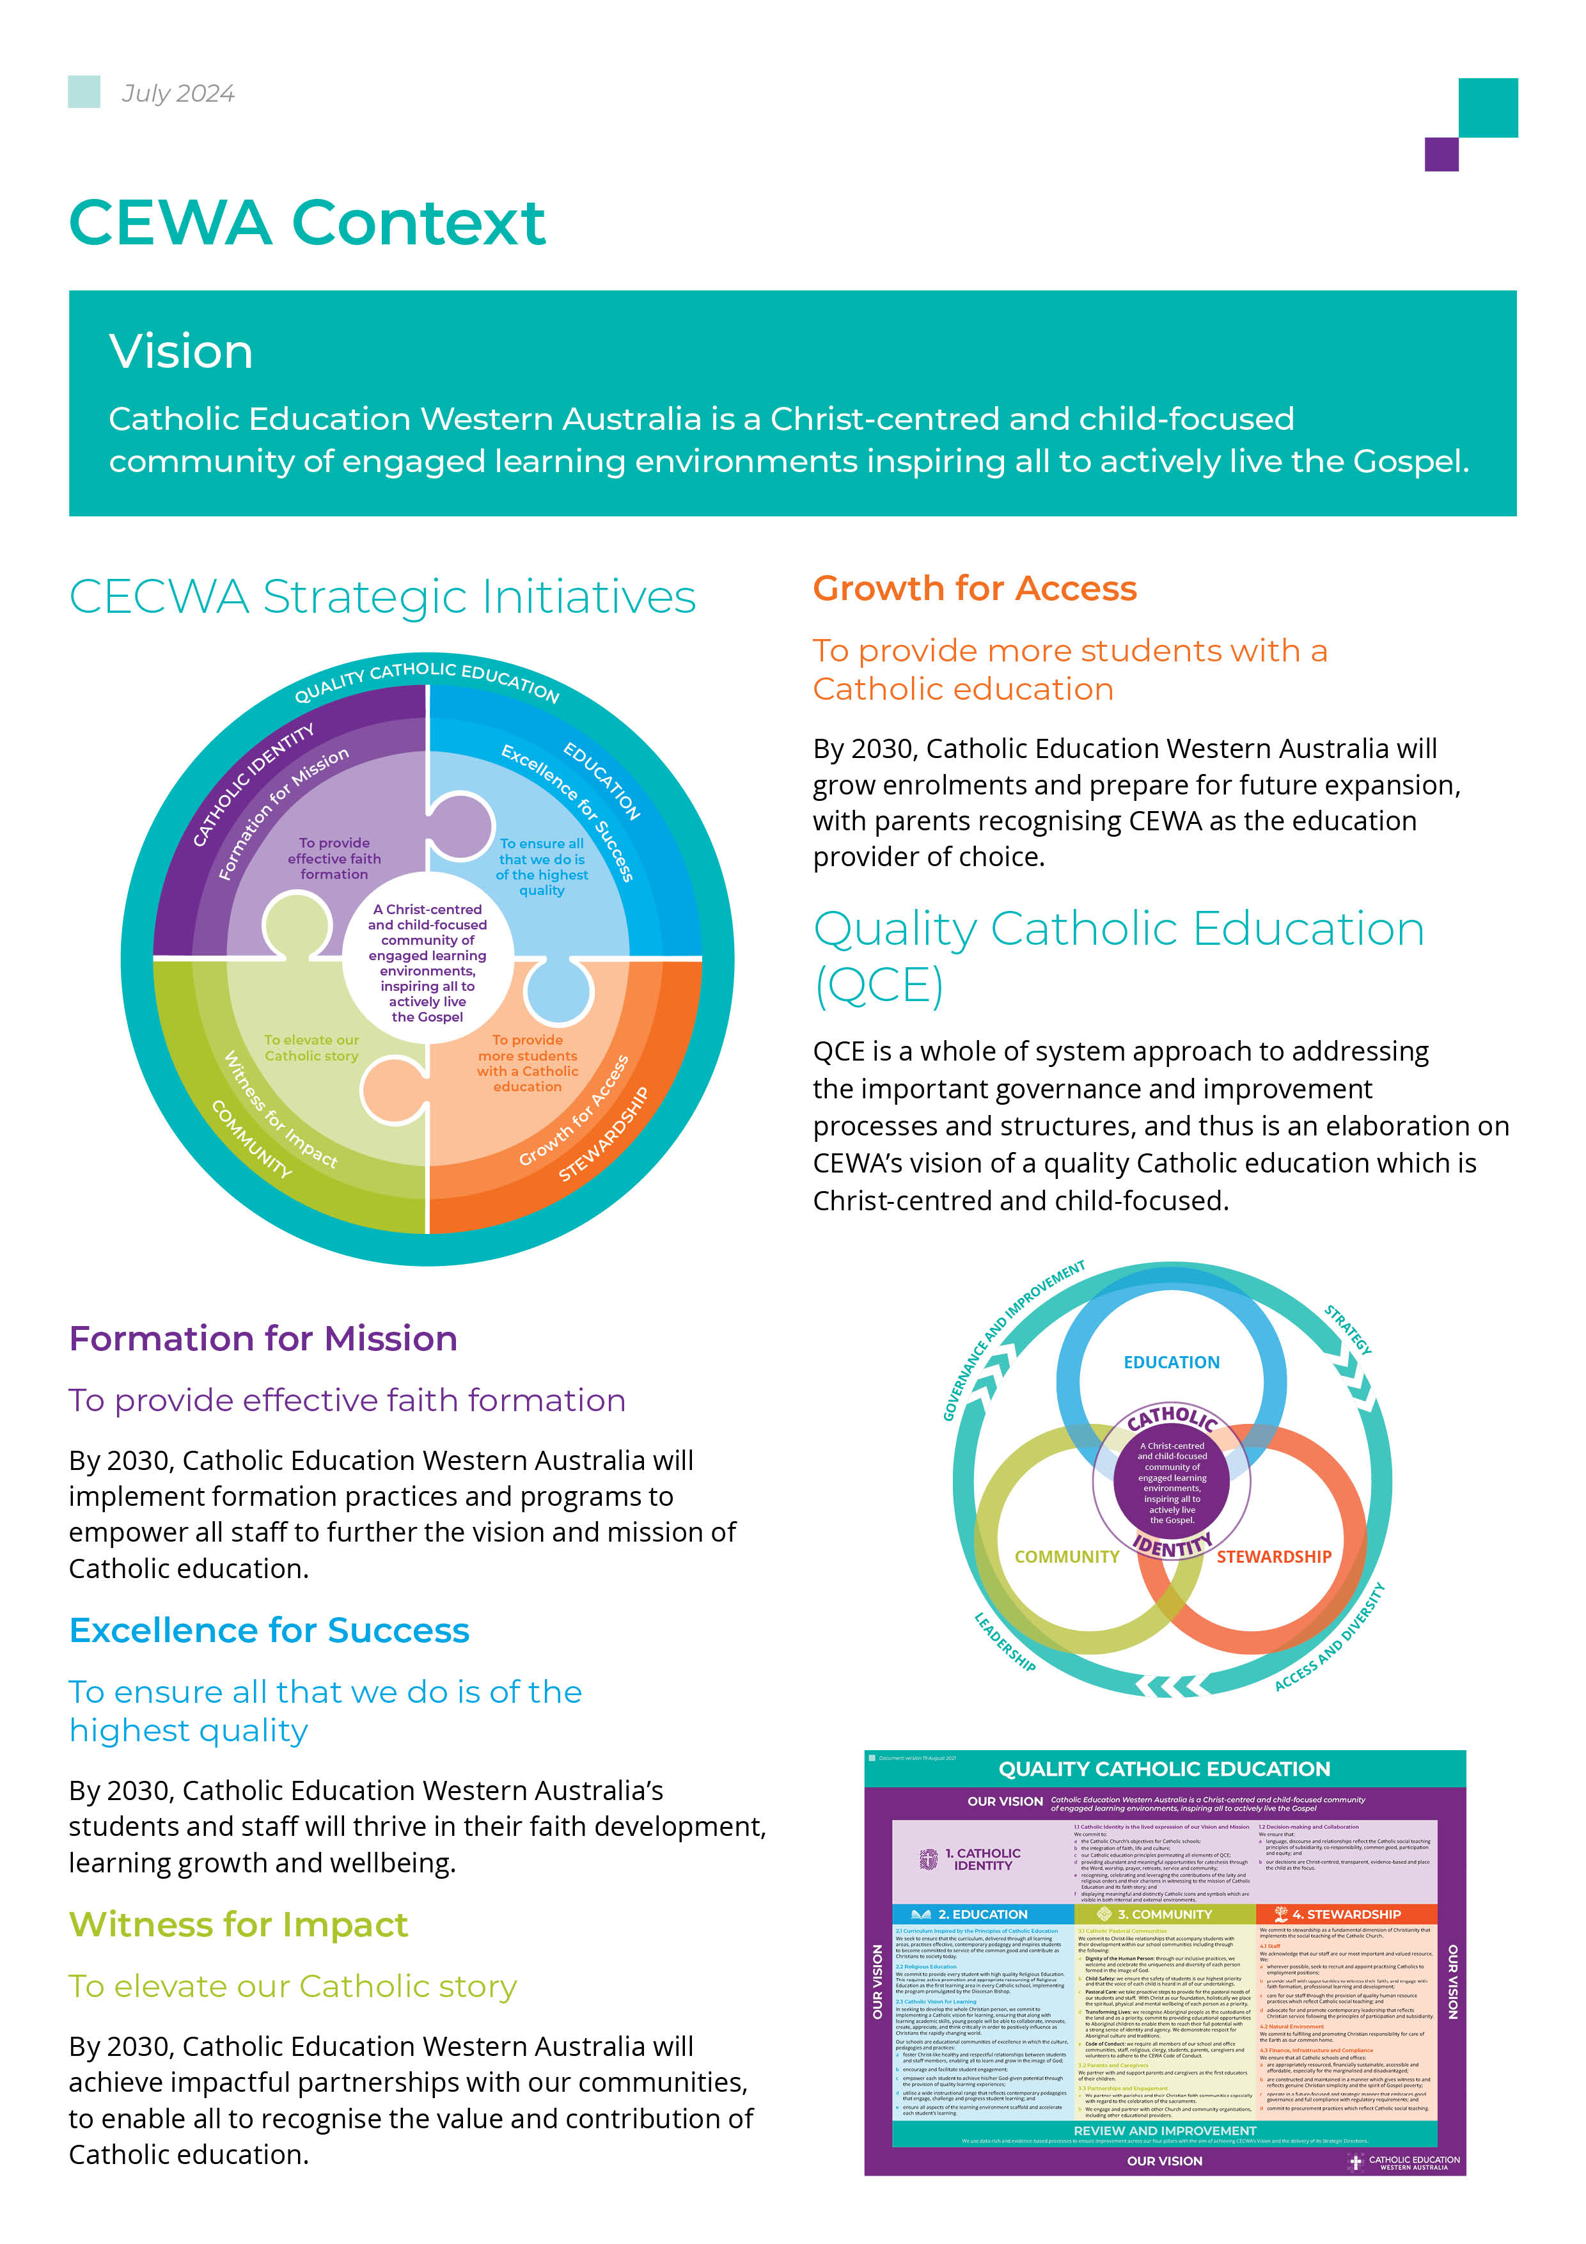
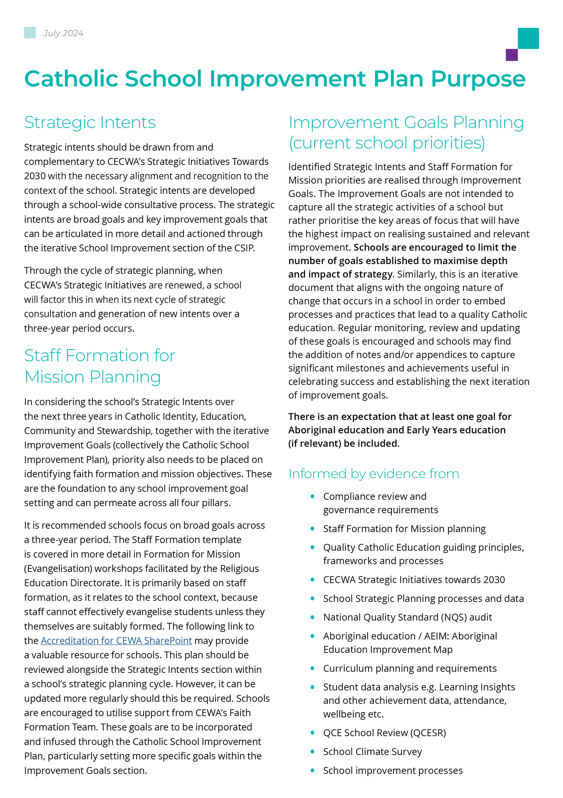
School Mission, Vision and Values
School Mission
“Never see a need, without doing something about it”

School Vision
We offer a contemporary Catholic Education that inspires hope and is inclusive of all. Centred on Christ, we provide high quality programs with a strong focus on taking action for good in the world.

Core Values
- We are honest and courageous and strive to follow in the footsteps of Jesus.
- We respect that we are all different and unique and are willing to share our talents with others.
- We demonstrate fairness to all in our school community.
- We engage in active learning in a safe and collaborative environment. We challenge, motivate and encourage everyone to reach their potential.
- We play our role in protecting God’s environment to promote a sustainable future for all.
Principal Statement
Our 2025–2027 School Improvement Plan sets a clear and ambitious agenda to strengthen our Catholic identity, enhance educational excellence and foster a welcoming and inclusive community. Guided by the Quality Catholic Education Framework, our strategic intents focus on deepening faith formation, embedding the rich traditions of St Joseph’s and ensuring that our Catholic ethos is visible and lived in every aspect of school life.

Over the next three years, we will prioritise high-impact teaching practices in Literacy and Numeracy to maximise student learning growth, while ensuring differentiated and engaging opportunities for all learners, including First Nations students, students with disability and culturally diverse learners. A key initiative will be the development and implementation of the Aboriginal Education Improvement Map (AEIM), integrating First Nations perspectives across all learning areas to promote cultural understanding and respect. Our Formation for Mission goals will guide staff and leadership development, ensuring that we model faith in action and create a culture of collaboration, inclusion and excellence. Together, as a school community, we will continue to nurture the spiritual, academic and personal growth of every child in our care.

Strategic Intents | 2025 – 2027

CATHOLIC IDENTITY. Formation for Mission
Strategic Intents | Key Improvement Goals | QCE Links | Year 1 | Year 2 | Year 3
Catholic etiquette practices. Focus on the meaning of relevant gestures, symbols and traditions within the Church and School why do we do them and how to teach them to students. | St Joseph’s School will strengthen its Catholic identity through regular prayer, liturgical celebrations, Religious Education, faith formation opportunities, and ongoing professional learning for staff. The school will foster a lived Catholic ethos by enhancing sacred spaces, promoting St Joseph’s charism, encouraging staff and student voice, and supporting stewardship, service, and social justice initiatives. Strong partnerships between the school, parish, and families will be nurtured through Masses, sacramental programs, faith formation events, and opportunities for shared prayer and worship. | - 1.1b  - 2.2  - 4.1b | 🟨 Progressing | 🔴 Not Started | 🔴 Not Started
To build staff capacity for faith-based leadership by enabling the identification and intentional use of individual gifts to enhance teaching, ministry, and community life. | St Joseph’s School will support staff in discovering, developing, and sharing their God-given gifts through reflection, prayer, professional learning, and meaningful discussions within professional growth processes. Staff will be encouraged to use their strengths in leadership, teaching, ministry, and collaboration, with opportunities to contribute their unique talents across the school community. A culture of recognition and celebration will be fostered by acknowledging staff contributions, sharing successes, and providing ongoing faith and leadership formation opportunities. | - 1.1b  - 1.1e  - 1.1f | 🟨 Progressing | 🔴 Not Started | 🔴 Not Started
Increase staff and student engagement in their own faith learning and faith formation. | St Joseph’s School will nurture faith through regular prayer, liturgy, Monday Mass, Religious Education, and programs such as Living Like Jesus, while providing ongoing professional learning in Catholic identity, spirituality, and the RE curriculum. Strong partnerships with families and the parish will support faith formation, sacramental programs, and opportunities for shared prayer, worship, and student leadership. The school will promote service, stewardship, and social justice, while encouraging staff to share and use their God-given gifts in meaningful ways that enrich the Catholic life of the school. |  | 🟨 Progressing | 🔴 Not Started | 🔴 Not Started
EDUCATION Excellence for Success
Strategic Intents | Key Improvement Goals | QCE Links | Year 1 | Year 2 | Year 3
Implement consistent, evidence-based whole-school practices to improve Literacy and Numeracy outcomes while ensuring every child has access to differentiated, engaging, and challenging learning opportunities that respect diversity and promote equity, including First Nations students, students with disability, and culturally diverse learners (EAL/D). | - To increase the capacity and pedagogical practices of staff to effectively teach and embed Literacy and Numeracy whole school approaches to achieve growth in student learning.  - (BFSA) Reduce the proportion of all students in the needs additional support proficiency level and developing proficiency level. 75% in the strong category by 2029.  - Students demonstrate measurable growth in targeted areas of learning  - Evidence of teacher’s learning objectives and teaching strategies supporting students’ individualised goals. | - 2.1  - 2.3c  - 2.3d  - 2.3e | 🟨 Progressing | 🔴 Not Started | 🔴 Not Started
Develop and implement a First Nations Improvement Map (AEIM) that prioritises First Nations education and ensures integration across all learning areas to promote cultural understanding, respect, and inclusion. | - Embed Aboriginal perspectives and cultural knowledge across all learning areas to promote understanding, respect, and inclusion for First Nations students and the wider school community.  - Strengthen staff capacity and confidence to implement the Aboriginal Education Improvement Map (AEIM) through professional learning, community partnerships, and culturally responsive teaching practices. | - 2.3  - 3.1a  - 3.1d  - 4.2 | 🟨 Progressing | 🔴 Not Started | 🔴 Not Started
COMMUNITY Witness for Impact
Strategic Intents | Key Improvement Goals | QCE Links
Build a welcoming, inclusive and collaborative school community that values partnerships, engagement and communication with community and families to be a strength of St. Joseph’s. | - Continue to endorse student and whole school achievements and activities to promote and market St. Joseph’s School.  - Maintain clear processes of communication to convey inclusivity to students, parents and the wider community to increase enrolments. | - 3.1 | 🟨 Progressing | 🔴 Not Started | 🔴 Not Started
Provide a school wide program to increase staff and student wellbeing. | - Continue Berry Street Education Model promoting resilience and wellbeing.  - Implement, promote and increase strategies from BSEM training modules in 2024 and 2025.  - PL/Workshops for new Staff to understand and implement strategies from BSEM  - Continue to ensure St. Joseph’s school remains a safe place for children, staff and the school community. | - 3.1 a-c | 🟨 Progressing | 🔴 Not Started | 🔴 Not Started
STEWARDSHIP Growth for Access
Strategic Intents | Key Improvement Goals | QCE Links
Ensure school facilities are maintained to a high standard. | - Development of a ten-year maintenance plan to address routine and preventative maintenance tasks.  - Conduct regular assessments of school facilities to identify areas needing repair and improvement | - 4.3c | 🟨 Progressing | 🔴 Not Started | 🔴 Not Started
Develop and foster school sustainability initiatives. | - Review current practices and update changes identified in school review.  - Implement sustainability initiatives in school and classrooms.  - PD/PLC dedicated to sustainability initiatives. | - 4.2 | 🟨 Progressing | 🔴 Not Started | 🔴 Not Started

Staff Formation Planning 2025-2027
FOCUS AREA ONE
What you want to improve: | Witness:  Modelling Faith in Action
Staff Formation | Relevant Actions (How?) | Timeline (When?) | Responsibility (Who?) | Effectiveness Indicators | Progress N/P/A
Improvement Goal:  (what do you hope to achieve?)  Catholic etiquette practices. Focus on the meaning of relevant gestures, symbols and traditions within the Church and School why do we do them and how to teach them to students. | - Regular and reflective prayer, Bible readings and liturgical celebrations integrated into the school calendar.  - Provide professional development/ workshops for staff on Catholic identity and spirituality (FSW, Accreditation to Teach RE).  - Ensure the school’s Catholic ethos is visible and lived in all aspects of school life.  - Enhance sacred spaces (classroom prayer areas, Admin. Office, Library).  - Professional Development & PLC’s – RE Team & Parish Priest.  - Use of RE Guidelines, RE Curriculum and sharing of resources.  - Continue Living Like Jesus fortnightly focus.  - Encourage staff and student voice in implementation of programs across the schools.  - Engage Families and Parish in Faith Development - Build strong partnerships between school, parish, and families to nurture faith. Family Masses, Parent Information Meetings  - Organise family faith formation evenings or workshops.  - Increase parish-school collaboration for Sacramental programs.  - Create opportunities for parents to participate in prayer and liturgy.  - Involve students in planning and leading prayer services.  - Regular class attendance at Monday Mass  - Support local and global charity initiatives (Caritas, Lifelink, Local Community Groups).  - Teach and involve students about stewardship and care for creation.  - Opportunities for Staff to share their gifts and how they can align and be implemented within the school.  - Promote symbols and traditions that reflect St Joseph’s charism | 2025 - Ongoing | - Principal  - Staff  - Students  - Parish Priest  - CEWA RE Team | - Confidence when participating and planning in Liturgy and Prayer  - Staff and students have increased understanding and modelling of Living Like Jesus values  - Opportunities to highlight and enact on Social Justice issues  - Feedback and participation from parents, students and staff  - Increased participation in voluntary roles  - Observable improvement in collaboration and morale  - Staff understand the tradition and history and values of St Joseph’s School | 1 | 🟨 Progressing
 |  |  |  |  | 2 | 🔴 Not Started
 |  |  |  |  | 3 | 🔴 Not Started
Leadership Formation | - Professional Development.  - Completion of Accreditation to Lead.  - Networking.  - Engaging with Parish Priest, Parish and Parents.  - Model Catholic etiquette and reverence during liturgies, assemblies, and meetings.  - Facilitate PD sessions/ workshops on Catholic traditions and their significance (with Parish Priest/RE Team).  - Ensure Catholic symbols and sacred spaces are visible and maintained.  - Communicate the meaning of gestures and traditions in newsletters and staff briefings.  - Mentor staff in integrating etiquette teaching into classroom prayer and RE lessons.  - Facilitate reflective opportunities (prayer meetings, PLC) for staff.  - Encourage staff to lead initiatives aligned with their gifts (music, art, social justice).  - Celebrate staff contributions in newsletters, assemblies, and meetings.  - Create collaborative structures (committees, PLCs) for staff to share and apply talents.  - Link staff gifts to school mission and faith-based programs (Living Like Jesus, Charity projects, Special Commemorative Days). | 2025 - Ongoing | Principal | - Staff report increased confidence in explaining Catholic gestures and traditions.  - Observations show consistent and reverent practices during liturgy and prayer.  - Sacred spaces and Catholic symbols are evident and respected.  - Students demonstrate understanding and correct practice of gestures in Mass and prayer.  - Increased staff participation in voluntary roles and faith initiatives.  - Positive staff survey results on feeling valued and connected to school mission.  - Evidence of staff-led programs enriching student faith formation.  - Stronger sense of collaboration and community observed in school culture. | 1 | 🟨 Progressing
Improvement Goal:  (what do you hope to achieve?)  Strengthen leadership capacity to model, promote, and embed Catholic etiquette, symbols, and traditions across the school community, ensuring leaders can articulate their meaning and guide staff in teaching these practices to students. |  |  |  |  | 2 | 🔴 Not Started
 |  |  |  |  | 3 | 🔴 Not Started
FOCUS AREA TWO
What you want to improve: | Catholic Identity
Staff Formation | Relevant Actions (How?) | Timeline (When?) | Responsibility (Who?) | Effectiveness Indicators | Progress N/P/A
Improvement Goal:  (what do you hope to achieve?)  To build staff capacity for faith-based leadership by enabling the identification and intentional use of individual gifts to enhance teaching, ministry, and community life. | Assist Staff discover & express Their Gifts  - Run simple workshops or reflection sessions  - Use prayer and discussion to help staff identify their strengths  Give Staff Opportunities to Use Their Gifts  - Match staff strengths to roles (e.g. prayer, music, wellbeing, social justice)  - Encourage all staff to take on leadership, not just those in formal roles  Include discussion of Gifts in Professional Growth Meetings  - Ask staff to reflect on their strengths in their GDP meetings  - Encourage them to use their talents in their teaching  Encourage Staff to Work Together  - Use PLC’s/ Staff Meetings to share skills and ideas  - Plan to learn together using individual Staff strengths  Support Ongoing Faith and Leadership Development  - Provide formation opportunities through Professional Development  - Investigate Retreat options for 2027  - Celebrate Staff Gifts  - Acknowledge staff contributions regularly  - Share examples in meetings or newsletters | 2026 Ongoing | - Principal  - Staff  - Students  - Parish Priest  - CEWA RE Team | - More staff can explain their strengths  - More staff take on leadership roles  - Greater involvement in prayer, liturgy, and service  - Improved staff confidence and wellbeing  - Stronger sense of shared mission | 1 | 🔴 Not Started
 |  |  |  |  | 2 | 🔴 Not Started
 |  |  |  |  | 3 | 🔴 Not Started
Leadership Formation | - Provide opportunities for staff to reflect on their strengths, gifts, and purpose (e.g. PLC’s, meetings, retreats).  - Offer training and support to connect faith with teaching and leadership.  - Encourage staff to use their strengths in different roles and leadership opportunities.  - Create time for staff to share ideas, support each other, and grow together.  - Regularly reflect and give feedback on how staff are using their gifts. | 2026 - Ongoing | - Principal  - Staff  - Students  - Parish Priest  - CEWA RE Team | - Staff feel more confident talking about and using their strengths.  - More staff are taking on leadership and ministry roles.  - Staff are using their strengths in their teaching and interactions.  - There is stronger teamwork and a positive staff culture.  - Students and families notice a stronger sense of faith and community. | 1 | 🔴 Not Started
Improvement Goal:  (what do you hope to achieve?)  To cultivate a culture of faith-informed leadership among staff by developing their capacity to recognise, articulate, and intentionally apply their individual gifts in teaching, ministry, and community engagement. |  |  |  |  | 2 | 🔴 Not Started
 |  |  |  |  | 3 | 🔴 Not Started

Improvement Goals (current and targeted school priorities drawn from the Strategic Intents)

CATHOLIC IDENTITY
Key Improvement Goals - drawn  from Strategic Intents  Performance & development goal to be  achieved (stated simply). | Relevant Actions  What actions will we take to achieve the goal? | Success Indicators  How will we know we have been successful? What process and outcome data will we measure? | Responsibility  Who is the staff member who will  lead the strategy? | Timeline  Timeframe within which the key improvement goal will be achieved | Progress  How are you tracking? Not commenced, Progressing, Achieved
- Increase staff and student engagement in their own faith learning and faith formation. | - Integrate regular prayer, Bible readings, liturgical celebrations, and Monday Mass into the school calendar.  - Continue initiatives like Living Like Jesus and encourage staff/student voice in faith programs.  - Provide PD and workshops on Catholic identity, spirituality, and RE curriculum (including Orientation, FSW & Accreditation).  - Facilitate PLCs with RE Consultants and Parish Priest; share RE guidelines and resources.  - Build strong partnerships with families and parish for faith development and Sacramental programs.  - Organise family faith formation evenings and create opportunities for parents to join prayer and liturgy.  - Involve students in planning and leading prayer services.  - Support local and global charity initiatives and teach stewardship and care for creation.  - Provide opportunities for staff to share their God-given gifts and integrate them meaningfully into school life.  - Provide PD and workshops on Catholic identity, spirituality, and RE curriculum (including Orientation, FSW & Accreditation). | Regular prayer, Bible readings, liturgical celebrations, and Monday Mass are consistently scheduled and attended with increased staff and student participation.  Positive feedback from staff and students on the spiritual life of the school.  100% staff participation in PD and workshops on Catholic identity and RE curriculum.  Staff demonstrate increased confidence and competence in teaching RE (classroom observations).  PLCs actively share RE resources and strategies.  Strong attendance at family faith formation evenings and parish-school events.  Positive feedback from families and parish on collaboration and faith development.  Active participation in charity initiatives and stewardship projects.  Evidence of student understanding of care for creation and social justice principles.  Staff share their gifts in school programs and events.  Participation rates of Professional Development:  Orientation: 100% of new staff within first semester.  FSW/Formation: 60% of staff complete planned sessions each semester.  Accreditation: 60% of staff actively on a pathway | Principal  Staff  Parish Priest | 2025 - Ongoing | 🟨 Progressing
- Catholic etiquette practices. Focus on the meaning of relevant gestures, symbols and traditions within the Church and School why do we do them and how to teach them to students. | - Ensure Catholic symbols, traditions, and St Joseph’s charism are evident in all aspects of school life.  - Enhance sacred spaces in classrooms and communal areas.  - Regular and reflective prayer, Bible readings and liturgical celebrations integrated into the school calendar.  - Provide professional development/ workshops for staff on Catholic identity and spirituality (FSW, Accreditation to Teach RE).  - Ensure the school’s Catholic ethos is visible and lived in all aspects of school life.  - Enhance sacred spaces (classroom prayer areas, Admin. Office, Library).  - Professional Development & PLC’s – RE Team & Parish Priest.  - Use of RE Guidelines, RE Curriculum and sharing of resources.  - Continue Living Like Jesus fortnightly focus.  - Encourage staff and student voice in implementation of programs across the schools.  - Engage Families and Parish in Faith Development - Build strong partnerships between school, parish, and families to nurture faith. Family Masses, Parent Information Meetings  - Organise family faith formation evenings or workshops.  - Increase parish-school collaboration for Sacramental programs.  - Create opportunities for parents to participate in prayer and liturgy.  - Involve students in planning and leading prayer services.  - Regular class attendance at Monday Mass  - Support local and global charity initiatives (Caritas, Lifelink, Local Community Groups).  - Teach and involve students about stewardship and care for creation.  - Opportunities for Staff to share their gifts and how they can align and be implemented within the school.  - Regular and reflective prayer, Bible readings and liturgical celebrations integrated into the school calendar.  - Provide professional development/ workshops for staff on Catholic identity and spirituality (FSW, Accreditation to Teach RE).  - Ensure the school’s Catholic ethos is visible and lived in all aspects of school life.  - Enhance sacred spaces (classroom prayer areas, Admin. Office, Library).  - Professional Development & PLC’s – RE Team & Parish Priest.  - Use of RE Guidelines, RE Curriculum and sharing of resources.  - Continue Living Like Jesus fortnightly focus.  - Encourage staff and student voice in implementation of programs across the schools.  - Engage Families and Parish in Faith Development - Build strong partnerships between school, parish, and families to nurture faith. Family Masses, Parent Information Meetings  - Organise family faith formation evenings or workshops.  - Increase parish-school collaboration for Sacramental programs.  - Create opportunities for parents to participate in prayer and liturgy.  - Involve students in planning and leading prayer services.  - Regular class attendance at Monday Mass  - Support local and global charity initiatives (Caritas, Lifelink, Local Community Groups).  - Teach and involve students about stewardship and care for creation.  - Opportunities for Staff to share their gifts and how they can align and be implemented within the school.  - Promote symbols and traditions that reflect St Joseph’s charism | Catholic symbols, traditions, and St Joseph’s charism are evident in classrooms and communal spaces.  Sacred spaces are maintained and used regularly for prayer and reflection.  Staff confidence growth in knowledge and understanding of history of St. Joseph’s  Confidence when participating and planning in Liturgy and Prayer  Staff and students have increased understanding and modelling of Living Like Jesus values  Opportunities to highlight and enact on Social Justice issues  Feedback and participation from parents, students and staff  Increased participation in voluntary roles  Observable improvement in collaboration and morale | - Principal  - Staff  - Students  - Parish Priest  - CEWA RE Team | 2025 - Ongoing | 🟨 Progressing

EDUCATION
Key Improvement Goals - drawn  from Strategic Intents  Performance & development goal to be  achieved (stated simply). | Relevant Actions  What actions will we take to achieve the goal? | Success Indicators  How will we know we have been successful? What process and outcome data will we measure? | Responsibility  Who is the staff member who will  lead the strategy? | Timeline  Timeframe within which the key improvement goal will be achieved | Progress  How are you tracking? Not commenced, Progressing, Achieved
Implement consistent, evidence-based whole-school practices to strengthen Literacy and Numeracy, ensuring every student achieves measurable learning growth. | - Assessment schedule adhered to and monitored.  - Develop and implement a Whole-School Pedagogical Framework for Literacy and Numeracy to ensure consistent, evidence-based teaching practices across all year levels.  - Use data to drive instruction: Collect and analyse multiple measures (NAPLAN, PAT, On-Entry, classroom assessments) to inform planning, interventions, and extension programs.  - Provide targeted professional learning to strengthen teacher content knowledge and pedagogical skills in Reading, Writing, Spelling, Grammar, and Numeracy.  - Differentiate learning and implement tiered supports (small-group interventions, enrichment programs) to meet diverse student needs. | 100% of teachers implement agreed Literacy & Numeracy practices with consistency.  Moderation sessions held at least once per term for writing and numeracy tasks.  Assessment schedule adhered to: On-Entry, PAT, NAPLAN, classroom assessments completed on time.  Data walls updated each term.  PLC meetings: Teachers meet at least twice per term to analyse data and plan next steps.  ≥60% of students in intervention groups achieve short-cycle goals.  Lesson plans & DWP’s show differentiation strategies  Student progress tracked using multiple measures (On-Entry, PAT, NAPLAN, classroom data).  ≥70% of students achieve at least one year’s growth annually. | Principal  Staff | 2025 - Ongoing | 🟨 Progressing
Develop and implement an Aboriginal Education Improvement Map (AEIM) to embed First Nations perspectives across all learning areas, fostering cultural understanding, respect, and inclusion. | - Staff to complete: AITSL Self- Reflection Aboriginal Perspectives prior to planned visit from consultants.  - AEIM developed with input from Staff and First Nations Consultants CEWA.  - Professional Learning: Provide staff PD on First Nations perspectives, histories, and pedagogical approaches. | AEIM completed and endorsed by leadership and CEWA First Nations consultants by the agreed timeline (e.g., Term 2 2026).  Staff input documented: ≥80% of staff contribute feedback during development phase.  Clear links to curriculum areas and school improvement priorities included in AEIM.  PD delivered: focused on First Nations perspectives, histories, and culturally responsive pedagogy. |  |  | 🔴 Not Started

COMMUNITY
Key Improvement Goals - drawn  from Strategic Intents  Performance & development goal to be  achieved (stated simply). | Relevant Actions  What actions will we take to achieve the goal? | Success Indicators  How will we know we have been successful? What process and outcome data will we measure? | Responsibility  Who is the staff member who will  lead the strategy? | Timeline  Timeframe within which the key improvement goal will be achieved | Progress  How are you tracking? Not commenced, Progressing, Achieved
Build a welcoming, inclusive, and collaborative school community that values strong partnerships, engagement, and clear communication with families and the wider community. | - Continue to endorse student and whole school achievements and activities to promote and market St. Joseph’s School  - Maintain clear processes of communication to convey inclusivity to students, parents and the wider community to increase enrolments.  - Parent, Staff, Student and Community Surveys. | Parent participation: ≥80% attendance at key events (e.g., parent nights, assemblies).  Community involvement: At least 2 community partnership projects per year (e.g., local organisations, parish).  Fortnightly newsletters sent on schedule.  Digital engagement: ≥70% of families regularly access school communication platforms (e.g., Seesaw, Social Media, Website).  Conduct at least 1 Parent/Staff/Student surveys per year. ≥80% overall satisfaction in annual parent/staff/student/ community survey.  Retention & enrolment: Maintain or grow enrolment numbers year-on-year. | Principal  Staff | 2025 ongoing | 🟨 Progressing
Provide a school wide program to increase staff and student wellbeing | - Embed Berry Street Education Model (BSEM) Practices  - Expand BSEM Strategies  - Professional Learning for new Staff on BSEM principles and strategies.  - Provide induction PL for new staff on BSEM principles and strategies.  - Promote a safe and supportive environment  - Review child safety policies annually.  - Conduct regular safety audits of physical spaces and wellbeing practices.  - Ensure all staff complete mandatory Child Protection Training (Annually).  - Conduct student, staff, and parent wellbeing surveys once per year.  - Analyse survey data to identify trends and areas for improvement.  - Share results and action plans with the school community. | Classroom walkthroughs show ≥80% of teachers consistently using BSEM strategies (e.g., predictable routines, brain breaks).  Visible BSEM language and visuals in 100% of classrooms.  Student engagement: ≥75% of students report feeling safe and supported (survey).  Expand BSEM Strategies: At least 2 additional BSEM strategies introduced each semester.  Teacher reflection logs show ≥80% of staff are applying new strategies within 4 weeks of training.  Professional Learning for New Staff delivered to 100% of new staff within first term.  4. Promote a Safe and Supportive Environment: Safety audits completed twice per year with ≥90% compliance on safety standards.  Mandatory Child Protection Training is completed by 100% of staff annually.  Wellbeing Surveys: Student, staff, and parent surveys conducted annually with ≥70% response rate.  Survey results show improvement in well-being indicators year-on-year (e.g., sense of safety, belonging).  Action plans developed and shared within 4 weeks of survey analysis.  PLC meetings are held each term to review well-being data and adjust strategies. | Principal |  | 🟨 Progressing

STEWARDSHIP
Key Improvement Goals - drawn  from Strategic Intents  Performance & development goal to be  achieved (stated simply). | Relevant Actions  What actions will we take to achieve the goal? | Success Indicators  How will we know we have been successful? What process and outcome data will we measure? | Responsibility  Who is the staff member who will  lead the strategy? | Timeline  Timeframe within which the key improvement goal will be achieved | Progress  How are you tracking? Not commenced, Progressing, Achieved
Maintain school facilities to a high standard through a scheduled maintenance plan and regular assessments to address repairs and improvements proactively. | - Maintenance Planning: Develop a maintenance schedule  - Regular Inspections & Assessments: Conduct termly site inspections and monthly safety walk-throughs (playgrounds, high-risk areas).  - Compliance & Safety: Schedule and document statutory checks (e.g., fire systems, emergency lighting, asbestos register updates, RCD testing). | Maintenance Schedule ≥95% of planned preventative tasks completed on time each term.  Inspections & Safety  Regular inspections: 100% of scheduled site inspections conducted and logged each term.  Hazard remediation: ≥95% of identified hazards rectified within agreed SLA (e.g., high risk ≤48 hours).  Emergency drills: 100% completed termly; post-drill action items closed within 2 weeks.  Compliance Statutory compliance: 100% of mandated checks up-to-date (fire, RCDs, emergency lighting, playground standards). | Principal  Admin  WHS Officer | 2025 Ongoing | 🟨 Progressing
Review and update practices identified in the school review, implement sustainability initiatives across the school and classrooms, and provide dedicated PD/PLCs to build staff capacity in sustainability. | - Reduce Environmental Impact: Implement initiatives such as recycling systems, energy-saving routines, water conservation, and biodiversity projects (e.g., native gardens).  - Professional Learning & Staff Formation: Provide PD and PLC sessions on Laudato Si, ecological spirituality, and practical sustainability strategies.  - Community Engagement & Advocacy: Involve families and parish in sustainability initiatives (e.g., waste-free lunch days, tree planting, Earth Hour, Laudato Si Week).  - Embed Laudato Si Themes in Curriculum: Integrate Catholic Social Teaching and Laudato Si principles into RE, Science, HASS, and cross-curricular projects. | Student projects demonstrate understanding of ecological responsibility (e.g., sustainability inquiry tasks).  ≥50% reduction in general waste by Term 4, 2026.  ≥10% reduction in electricity and water use year-on-year.  At least 1 biodiversity project completed annually  Staff attend at least one sustainability/Laudato Si PL annually.  Termly progress review and updates at PLC shared with staff and community. | Principal  Staff  Students | 2025 Ongoing | 🟨 Progressing

Ongoing Monitoring and Reflection
Record any key milestones that recognise attainment and/or changes in strategy
(This can include achievement of Improvement Goals, changes to Formation for Mission goals, modifications to Strategic Intents and/or any other important school improvement strategies)

Date | Progress, notes and key points
2025 | BSEM: Training Modules Completed by Staff. Morning Circle, Ready to Learn and Brain Breaks introduced – whole school and classrooms
2025 | Growth Development & Planning Meetings – GDP: Consistent 2 times per year. Planning: 1 x per term (week 3) – Meetings: Discussions on PD, Well-Being, Goals, Improvements, Strategies and application
2025 | Communication & Marketing is at a high standard and continues to be a priority.
2025 | Principal/Admin/CEWA Infrastructure Team: Planned maintenance and upgrades
2025 | Admin have collated a School Facilities & Maintenance Schedule for maintenance and upgrades
2025 | Implementation of fortnightly Staff Prayer at 8.15pm on Wednesday.
2025 | Reintroduction of Individual Classes attending Mass on Mondays when Parish priest is in Southern Cross
2025 | All Staff placed on Liturgy roster to prepare and deliver whole school Masses (Parish Priest/ Principal guide)
2025 | Sustainability Initiatives implemented: Produce Garden, Containers for Change, Continue Recycling, Energy efficient strategies, Laudato si PD delivered by CEWA Consultants
2025 | Initial Consultation & PD with CEWA First Nations Consultant (Leon) – Follow up visit from Heather & Chloe (CEWA Consultants) PD planned for Term 1, 2026 to develop AEIM
2025 | All classrooms have sacred places, & visual posters of the sacraments and prayers are evident.
2025 | All Staff completed Faith Story Witness
2026 | Staff requiring Orientation – Completed June 2026
2026 | Assessment Schedule continues to be adhered to in 2026 with new staff

Ongoing Monitoring and Reflection
Record any key milestones that recognise attainment and/or changes in strategy
(This can include achievement of Improvement Goals, changes to Formation for Mission goals, modifications to Strategic Intents and/or any other important school improvement strategies)

Date | Progress, notes and key points

